**Process Design**

**of a**

**Shell and Tube**

**Heat Exchanger**

**Group-6 Members**: -

**Name**-Yash Jhunjhunwala

**Roll No.**-18CH10070

**Name**-Anshuman Agrawal

**Roll no.**-18CH10071

**Problem Statement:**

* Kerosene (42o API) is required to be cooled from 110°C to 40°C by supplying cooling water (10o API) stream from 33 °C to 45 °C.
* The maximum pressure drop of 0.7 kg/cm2 for both streams is permissible.
* Design for a 1-2 shell and tube heat exchanger for this service.
* Flow rate of kerosene: - $\frac{75000}{Z}$ +(500×Z) kg/h where Z is our group number.
* Considering 1’’ OD tubes on 1.25’’ triangular pitch, 16 ft length.

**Schematics:**

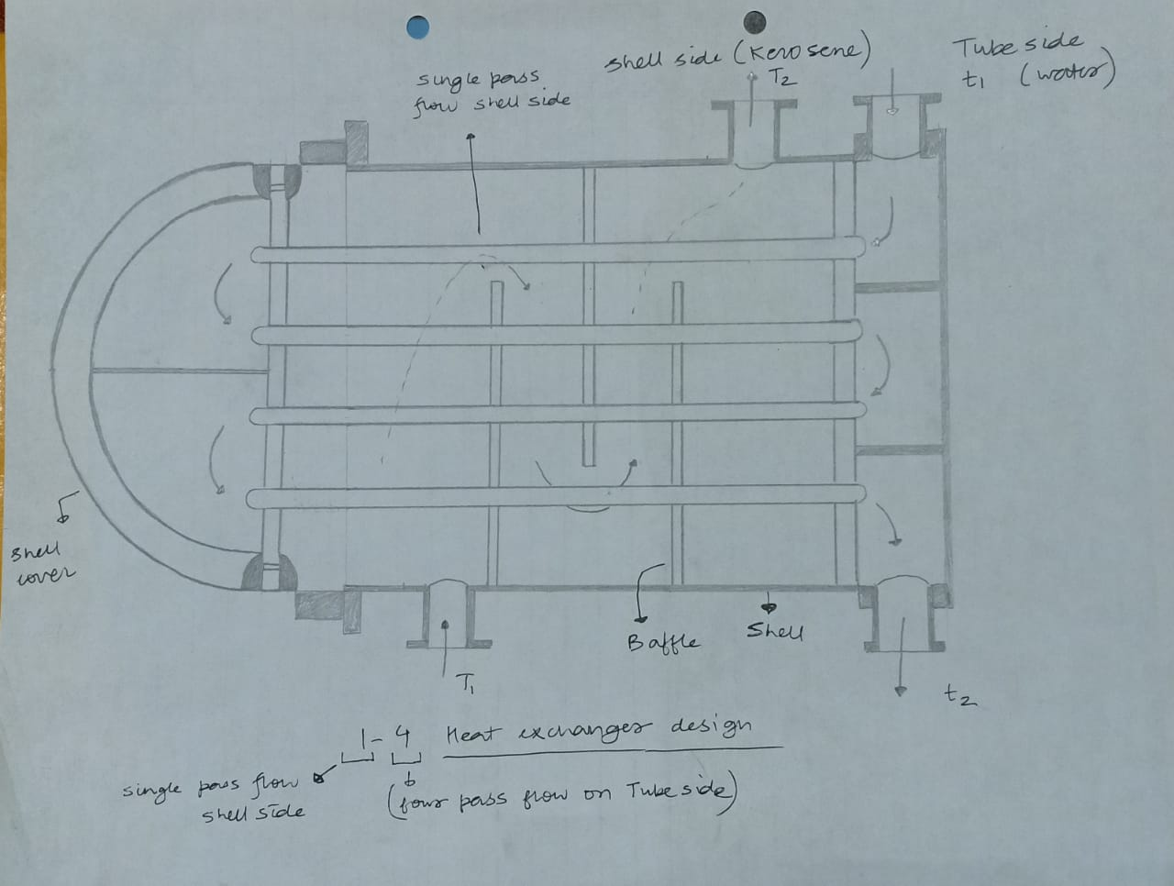

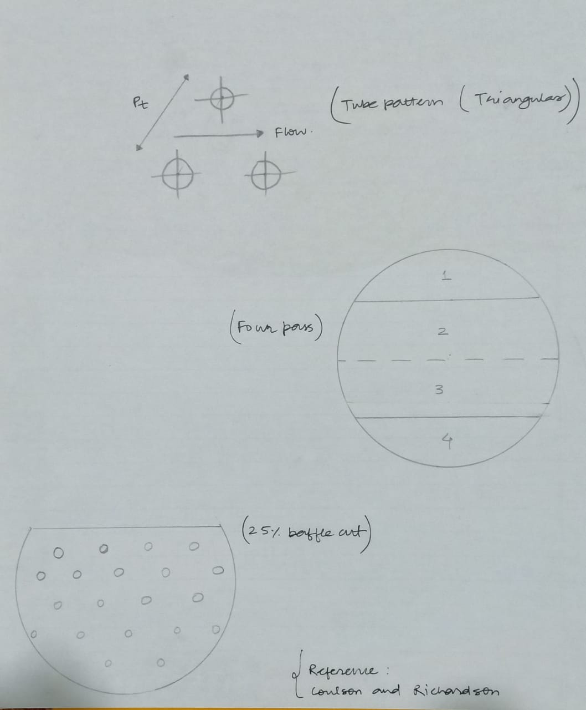

**Design Calculations to Follow from the Next Page….**